Nutritional Choices and their Correct Amounts.
For a simple way to eating healthy and the correct amount, a serving chart will be highly recommended. Many people have their preferences when it comes to food, some like it raw others just vegans or strictly off gluten. A healthy serving chart includes a wide range of vegetables, beans, fruits, whole grains, fish, nuts, poultry as well as low-fat or fat-free dairy products. There should be a limit of sweets, processed meats, salty, solid fats and sugary drinks.
A person should have a total of 2,000 calories per day. The calories are determined depending on the age or activity level and whether one is trying to gain, maintain or lose weight. One can check the nutritional fact label on packaged foods to get to know the recommended serving size, which is often less than the amount one is used to and be conscious of portion distortion.
Fats and Oils
Unsaturated is most preferred
Three servings a day
Examples:
- 1 tbsp vegetable oil (olive, corn, sunflower)
- 1 tbsp margarine
- 1 Tbsp salad dressing
Vegetables
Frozen, canned, fresh and dried
Five servings per day
Examples:
- ¼ cup pure vegetable juice
- 1 cup leafy greens
- ½ cup cooked beans
Grains
Half of it should be at least a whole grain that has high fibre
Six servings a day
Examples:
- 1 cup of cereal flakes
- ½ cup cooked rice, cereal or pasta
- 1 slice of bread.
Poultry, meat and eggs
Lean with removed skin and visible fat
Eight to nine servings a week
Examples:
- 1 egg or 2 egg whites
- 3 oz cooked chicken or meat
Nuts, beans seeds, and Legumes
Five servings a week
Examples:
- ¼ cup cooked beans
- 1 Tbsp peanut butter
- 2 Tbsp seeds or nuts
Dairy
Fat-free or Low -fat
Three servings a day
Examples:
- 1 cup milk
- 1.5 0z cheese
- 1 cup yoghurt

Featured Image


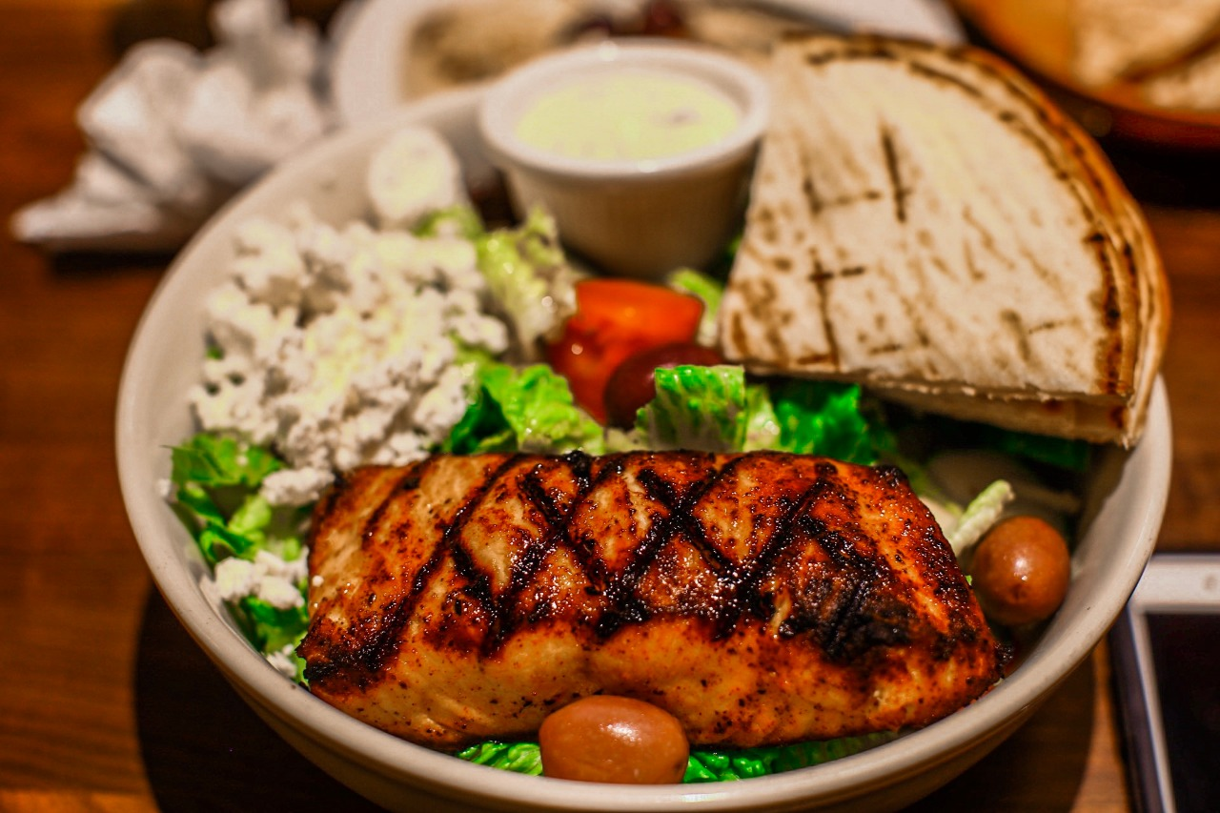
Links
https://www.helpguide.org/articles/healthy-eating/high-fiber-foods.htm

